Prague University of Economics and Business
Master’s Thesis
2010 Roman Smetana
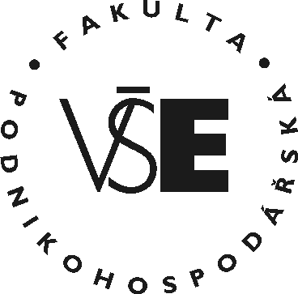
Prague University of Economics and Business
Faculty of Business Administration
Master’s Field: International management

Title of the Master’s Thesis:
Analysis of Mergers and Acquisitions
in the Czech Republic
Author: Roman Smetana
Supervisor: prof. Ing. Ignác David, CSc.

Declaration of Authenticity
I hereby declare that the Master’s Thesis presented herein is my own
work, or fully and specifically acknowledged wherever adapted from
other sources. This work has not been published or submitted
elsewhere for the requirement of a degree programme.
Prague, August 20, 2011 Signature

Title of the Master’s Thesis:
Analysis of Mergers and Aquisitions in the Czech Republic

Abstract:
Concise review of goals, methods, processes, results and conclusions of the Master’s Thesis within the range of cca 10 lines. Concise review of goals, methods, processes, results and conclusions of the Master’s Thesis within the range of cca 10 lines. Concise review of goals, methods, processes, results and conclusions of the Master’s Thesis within the range of cca 10 lines. Concise review of goals, methods, processes, results and conclusions of the Master’s Thesis within the range of cca 10 lines. Concise review of goals, methods, processes, results and conclusions of the Master’s Thesis within the range of cca 10 lines. Concise review of goals, methods, processes, results and conclusions of the Master’s Thesis within the range of cca 10 lines. Concise review of goals, methods, processes, results and conclusions of the Master’s Thesis within the range of cca 10 lines.

Key words:
Listing 3 to 5 key words characterizing the subject-matter of the Master’s Thesis

