University of Economics, Prague
Master’s Thesis
2010 Roman Smetana
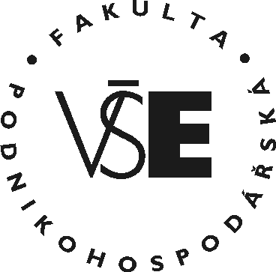
University of Economics, Prague
Faculty of Business Administration
Master´s Field: International management

Title of the Master´s Thesis:
Analysis of Mergers and Acquisitions
in the Czech Republic
Author: Roman Smetana
Supervisor: prof. Ing. Ignác David, CSc.

Declaration of Authenticity
I hereby declare that the Master´s Thesis presented herein is my own
work, or fully and specifically acknowledged wherever adapted from
other sources. This work has not been published or submitted
elsewhere for the requirement of a degree programme.
Prague, August 20, 2011 Signature

Title of the Master´s Thesis:
Analysis of Mergers and Aquisitions in the Czech Republic

Abstract:
Concise review of goals, methods, processes, results and conclusions of the Master´s Thesis within the range of cca 10 lines. Concise review of goals, methods, processes, results and conclusions of the Master´s Thesis within the range of cca 10 lines. Concise review of goals, methods, processes, results and conclusions of the Master´s Thesis within the range of cca 10 lines. Concise review of goals, methods, processes, results and conclusions of the Master´s Thesis within the range of cca 10 lines. Concise review of goals, methods, processes, results and conclusions of the Master´s Thesis within the range of cca 10 lines. Concise review of goals, methods, processes, results and conclusions of the Master´s Thesis within the range of cca 10 lines. Concise review of goals, methods, processes, results and conclusions of the Master´s Thesis within the range of cca 10 lines.

Key words:
Listing 3 to 5 key words characterizing the subject-matter of the Master´s Thesis

